Graphics Output on the HSA_UFA Console

# Introduction

You already know that the Console window can output text, laid out in rows and columns of **characters** (any letter, number, punctuation mark, space, etc. is a character).

But the Console can also output graphics, and for that you have to think of it as laid out in rows and columns of **pixels** (a pixel is the smallest dot of color that can appear on a computer screen).

# Graphics Output

For graphics, the console is divided into **x and y coordinates**. Each x and y coordinate identifies a single pixel. The top left corner is x=0 and y=0. Whenever you draw a shape, you usually have to specify an x and y starting position, and at least a width and height for the shape, in pixels.

x = 0, y = 0

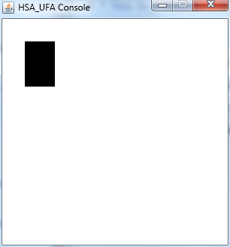

y coordinates increase

from top to bottom

x coordinates increase from left to right

height = 60 pixels

width =

40 pixels

x = 30, y = 30

# Basic Graphics Methods

**setColor** (Color)

Sets the drawing color for all output methods except print and println (use setTextColor and setTextBackgroundColor for those methods).

**drawLine** (x1, y1, x2, y2)

Draws a line from (*x1*, *y1*) to (*x2*, *y2*).

**drawRect** (x, y, width, height)

Draws a rectangle with upper-left corner at (*x*, *y*) with width of *width* and height of *height*.

**fillRect** (x, y, width, height)

Draws a filled rectangle with upper-left corner at (*x*, *y*) with width of *width* and height of *height*.

**drawOval** (x, y, width, height)

(*x*,*y*)

*height*

*width*

Draws an oval. The oval is inscribed in the rectangle defined by the upper-left corner (*x*, *y*) with width of *width* and height of *height*.

**fillOval** (x, y, width, height)

Draws a filled oval. The oval is inscribed in the rectangle defined by the upper-left corner (*x*, *y*) with width of *width* and height of *height*.

**drawMapleLeaf** (x, y, width, height)

Draws a maple leaf. The maple leaf is inscribed in the rectangle defined by the upper-left corner (*x*, *y*) with width of *width* and height of *height*.

**fillMapleLeaf** (x, y, width, height)

Draws a filled maple leaf. The maple leaf is inscribed in the rectangle defined by the upper-left corner (*x*, *y*) with width of *width* and height of *height*.



(*x*,*y*)

*width*

*height*

**drawStar** (x, y, width, height)

Draws a star inscribed in the rectangle defined by the upper-left corner (*x*, *y*) with width of *width* and height of *height*.

**fillStar** (x, y, width, height)

Draws a filled star inscribed in the rectangle defined by the upper-left corner (*x*, *y*) with width of *width* and height of *height*.

# Better Text Output

**drawString** (str, x, y)

Draws the string *str* at the starting point (*x*, *y*). The *y* coordinate is the bottom of the text.

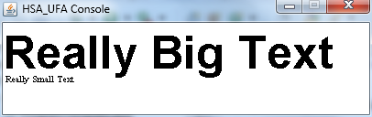**setFont** (Font)

Sets the font for the drawString method, but does not affect print or println. See the font handout.

# Advanced Graphics Methods

**drawRoundRect** (x, y, width, height, arcWidth, arcHeight)

Draws a rectangle with rounded corners with upper-left corner at (*x*, *y*) with width of *width* and height of *height*. *arcWidth* and *arcHeight* are the width and height of the ellipse used to draw the rounded corners.

**fillRoundRect** (x, y, width, height, arcWidth, arcHeight)

Draws a filled rectangle with rounded corners with upper-left corner at (*x*, *y*) with width of *width* and height of *height*. *arcWidth* and *arcHeight* are the width and height of the ellipse used to draw the rounded corners.

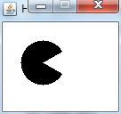

**c.fillArc (20, 20, 50, 50,**

**30, 300);**

**drawArc** (x, y, width, height, startAngle, arcAngle)

Draws an arc. The arc is inscribed in the rectangle defined by the upper-left corner (*x*, *y*) with width of *width* and height of *height*. It starts at *startAngle* degrees and goes counterclockwise for *arcAngle* degrees.

**fillArc** (x, y, width, height, startAngle, arcAngle)

Draws a filled arc. The arc is inscribed in the rectangle defined by the upper-left corner (*x*, *y*) with width of *width* and height of *height*. It starts at *startAngle* degrees and goes counterclockwise for *arcAngle* degrees.

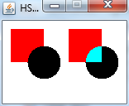**setPaintMode** ()

All drawing will now cover whatever is underneath it.

**setXORMode** (backgroundColor)

Any time you draw over something, it will show through. (Technically, the new shape is XOR'd with the background.) You must specify the background color to stop it from showing through when you draw.

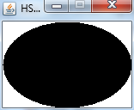**getDrawHeight** ()

Returns the height of the drawing area in pixels. For example, you could use *getHeight()* in place of the width number in a call to *drawOval()*, and the oval will be as wide as the screen.

**getDrawWidth** ()

Returns the width of the drawing area in pixels. For example, you could use *getWidth()* in place of the width number in a call to *drawOval()*, and the oval will be as wide as the screen.

**c.fillOval(0,0,c.getDrawWidth(),c.getDrawHeight());**